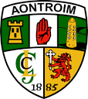

ANTRIM UNDER 14 HURLING DEVELOPMENT SQUAD 2018
FOOD & PHYSICAL ACTIVITY DIARY

NAME:_____________________________________________________ DATE:_____________________________________

 | Monday | Tuesday | Wednesday | Thursday | Friday | Saturday | Sunday
Breakfast
Lunch
Dinner
Snacks
Water Intake

Activity

