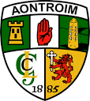

ANTRIM UNDER 14 HURLING DEVELOPMENT SQUAD 2018
CARE CONTRACT

7 JANUARY 2018

COMMITMENT | APPLICATION | RESPECT | EXCELLENCE
FOR REVIEW IN MARCH 2018

Name | Name | Name | Name

