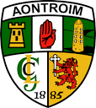

**ANTRIM UNDER 14 HURLING DEVELOPMENT PANEL**

**COACHING & GAMES PLAN (7 JANUARY – 25 AUGUST 2018)**



**Contact Details for U14 Lead Coaches**

* Declan Heggarty (Lead - Slemish) Ballycastle (07595362912)
* Paul Donnelly (Lead - Casement) St Paul’s (07837419976)

|  |  |  |  |
| --- | --- | --- | --- |
| **COMMITMENT** | **APPLICATION** | **RESPECT** | **EXCELLENCE** |